EU Declaration of Conformity

PRODUCT TYPE: Bicycle Helemt

MANUFACTURER: DongGuan Lucky Sonics Co.,Ltd

This declaration of conformity is issued under the sole responsibility of DongGuan Lucky Sonics Co.,Ltd (Room 801, Building A1, Guangda WE Valley, Road 2, SongShan Lake, North Industrial Zone, DongGuan City, GuangDong Province,China)

PRODUCT ID: SH50 (with BA30)

PRODUCT IMAGE/S:
(Insert photo’s)

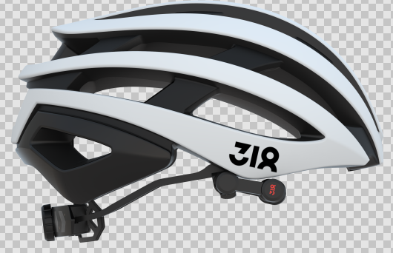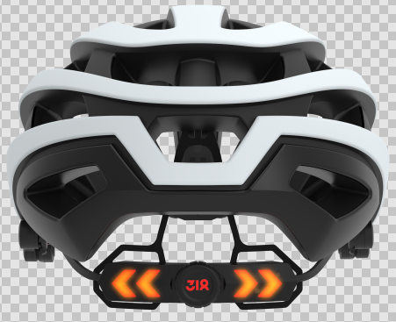

The above product is in conformity with the regulation (EU) 2016/425 and is identical to the PPE which is subject of EU certificate…………………………. issued by:

ITS Testing Services UK Ltd
Centre Court, Meridian Business Park,
Leicester, LE19 1WD,
United Kingdom
NB 0362

Relevant Harmonized Standards / Technical Specifications used to which conformity is declared:
EN 1078

Signed for on behalf of DongGuan Lucky Sonics Co.,Ltd

Date: 2019-01-10

Name: Michael Lee

Position: Product Manager

Signature:

